New Physio Led HIIT Lunchtime Class
**30min workout during your lunch break**

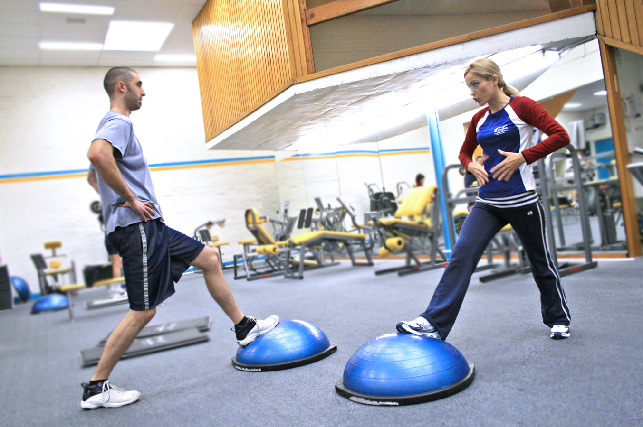

· Core strengthening to help improve lower back pain;
· Fat loss;
· Increased endorphin release;
· Break from work – better psychological state;
· Physio led to ensure no injury occurs;
· Better cardiorespiratory fitness;

WHEN: WEDNESDAYS. COMMENCING JUNE 14TH 2017.
WHERE: THE WESTMINSTER PHYSIOTHERAPY AND PILATES CENTRE.
TIME: 12.30-1PM.
DURATION: 1/2 HOUR.
LEVEL: MIXED ABILITY.
COST: £80 FOR 6 WEEKS OR £15 PER CLASS.

Limited spaces, so please book early to avoid disappointment. Please contact reception at WPPC on 0207 834 3700 or email us at reception@westminsterphysio.co.uk

